**MID COAST FUTSAL-WIN TELEVISION ANNUAL SUMMER CUP**

**SAT & SUN 22NDAND 23RD FEBRUARY 2020**

Open to teams of all abilities.

**Venue: St Columba Anglican School**

**(2courts) – 3 Iona Ave. Port Macquarie**

Age Groups: u8’s, u10’s, u12/13’s

Entry fee $240

* Youth/Men’s entry fee $260

*PRIZEMONEY $500 TO WINNER

(MIN 6 TEAMS)

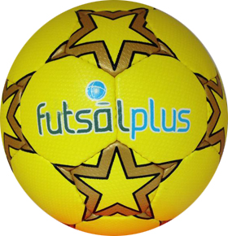

Register and info [www.midcoastfutsal.com](http://www.midcoastfutsal.com)

Email [alison@midcoastfutsal.com](mailto:alison@midcoastfutsal.com)

Mobile Alison 0412 191923 – 0411 501 744